19.39: See Exercise 19.32. a)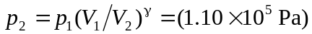
b) Using Equation (19.26),
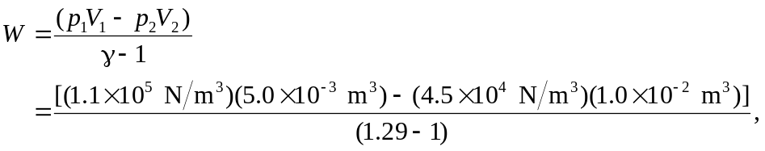

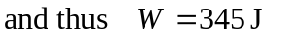 The final temperature is lower than the initial temperature, and the gas is cooled.

